** MINISTRY OF EDUCATION AND TRAINING**

**FPT UNIVERSITY**

Capstone Project Document

Student Finance Management

|  |  |
| --- | --- |
| **Group 2** | |
| **Group members** | Tran Khac Vy – Team Leader – SE60964  Ho Doan Trung – Team Member – SE60882  Tran Quang Phuc – Team Member - SE60993  Vu Nhat Anh Khoa – Team Member – SE60817  Le Tuan Anh – Team Member – SE60685 |
| **Supervisor** | Mr. Kieu Trong Khanh |
| **Ext. Supervisor** | N/A |
| **Capstone Project code** | SFM |

-Ho Chi Minh City, 09/2015-*This page is intentionally left blank*

***ACKNOWLEDGEMENTS***

We wish to thank various people for their contribution to this project: Our teachers for their advice and participation in the final review, our friends for their valuable technical support.

Special thanks should be given to Mr.Kiều Trọng Khánh, our research supervisor for his professional guidance and the useful, constructive recommendations throughout the course of this project.

# Table of Contents

Table of Contents 4

List of Tables 5

List of Figures 6

Definitions, Acronyms, and Abbreviations 8

Report No.3 Software Requirement Specification 9

1. User Requirement Specification 9

1.1 Guest Requirement 9

1.2 Member Requirement 9

1.3 Staff Requirement 9

1.4 Admin Requirement 9

1.5 System Requirement 9

2. System Requirement Specification 9

2.1 External Interface Requirement 9

2.2 System Overview Use Case 10

2.3 List of Use Case 10

3. Software System Attribute 48

3.1 Usability 48

3.2 Reliability 48

3.3 Availability 48

3.4 Security 48

3.5 Maintainability 48

3.6 Portability 48

3.7 Performance 49

4. ERD 50

# List of Tables

Table 1: <Admin> Configure System 11

Table 2: <Admin> Make Statistics 12

Table 3: <Admin> Create User 14

Table 4: <Admin> Update User 15

Table 5: <Admin> Activate User 16

Table 6: <Admin> Deactivate User 17

Table 7: <Admin> Force Parse Data 19

Table 8: <System> Auto Parse Data 20

Table 9: <Staff> Create Market 23

Table 10: <Staff> Update Market 25

Table 11: <Staff> Deactivate Market 26

Table 12: <Staff> Activate Market 28

Table 13: <Staff> Import File 30

Table 14: <Staff> Manually Input 32

Table 15: <Staff> Update Product 33

Table 16: <Staff> Deactivate Product 34

Table 17: <Staff> Activate Product 36

Table 18: <Member> Ask For System Suggestion 37

Table 19: <Member> Search Product and View Product Price 39

Table 20: <Member> Add Product To Cart 40

Table 21: <Member> Propose Price 41

Table 22: <Member> Save Product History 42

Table 23: <Member> Logout 43

Table 24: <Guest> Login 45

Table 25: <Guest> Register 47

# List of Figures

Figure 1: System Overview Use Case 9

Figure 2: <Admin> Overview use case 10

Figure 3: <Admin> Configure System 10

Figure 4: <Admin> Make Statistics 11

Figure 5: <Admin> Create User 12

Figure 6: <Admin> Update User 14

Figure 7: <Admin> Active User 15

Figure 8: <Admin> Deactivate User 16

Figure 9: <Admin> Force Parse Data 18

Figure 10: <System> Overview Use Case 19

Figure 11: <System> Auto Parse Data 19

Figure 12: <Staff> Overview Use Case 21

Figure 13: <Staff> Create Market 21

Figure 14: <Staff> Update Market 23

Figure 15: <Staff> Deactivate Market 25

Figure 16: <Staff> Activate Market 27

Figure 17: <Staff> Import File 28

Figure 18: <Staff> Manually Input 30

Figure 19: <Staff> Update Product 32

Figure 20: <Staff> Deactivate Product 33

Figure 21: <Staff> Activate Product 35

Figure 22: <Member> Overview Use Case 36

Figure 23: <Instructor> Ask For System Suggestion 36

Figure 24: <Member> Search Product and View Product Price 37

Figure 25: <Member> Add Product To Cart 39

Figure 26: <Member> Propose Price 40

Figure 27: <Member> Save Product History 41

Figure 28: <Member> Logout 43

Figure 29: <Guest> Overview Use Case 44

Figure 30: <Guest> Login 44

Figure 31: <Guest> Register 45

Figure 35: ERD - Conceptual Diagram 49

# Definitions, Acronyms, and Abbreviations

|  |  |
| --- | --- |
|  |  |

# Software Requirement Specification

## User Requirement Specification

### Student Requirement

Sinh viên là người sử dụng dịch vụ của hệ thống. Trong hệ thống hiện tại có 3 loại sinh viên là :

* Sinh viên thông thường
* Sinh viên vay vốn tín dụng
* Sinh viên thuộc dạng “Cùng bạn đầu tư”

Tất các các sinh viên đều có thể sử dụng một số chức năng dưới đây :

* Xem quá trình học tập
  + Xem các học kỳ đã học
  + Xem danh sách các môn học chưa hoàn thành (bao gồm các môn đang nợ hoặc các môn chưa đủ điều kiện để học nếu có)
* Xem tình trạng tài chính
* Xem tình trang nộp học phí của các kỳ đã học
* Xem tính trạng nộp học phí của các môn nợ (nếu có)
* Xem và cập nhật thông tin cá nhân

### Staff Requirement

Staff is the person who manages markets and products. Staff can use these functions:

* Manage market.
* Manage product.

### Manager Requirement

Member is guest who uses his account to login to the system. Member can use additional functions, such as:

* Update product price.
* Save product history.

### Admin Requirement

Admin is the person who manages the system. Admin can use these functions:

* Configure system.
* Make statistics.
* Manage user.

## System Requirement Specification

### External Interface Requirement

#### User Interface

* + The interface of website is clear, do not annoy customer.
  + The interface of mobile app must be clear, compatible with touch screen. The size of controls must be big enough to touch on smartphone.
  + The error, warning messages must be make clear, easy to understand. Error warning does not disturb customer.

#### Hardware Interface

* + The system will use the standard hardware and data communications resources of a standard computer.

#### Software Interface

* + Firefox Browser, Chromes with Resolution (1280*800) or bigger and support JavaScript and HTML5
  + Smartphone with Android 4.1 or above. Screen size (70 x 120 mm) or bigger.

#### Communication Protocol

* Website using HTTP protocol for communication between the web browser and the web server.
* Mobile app using HTTP protocol for communicating between app and web service.

### System Overview Use Case

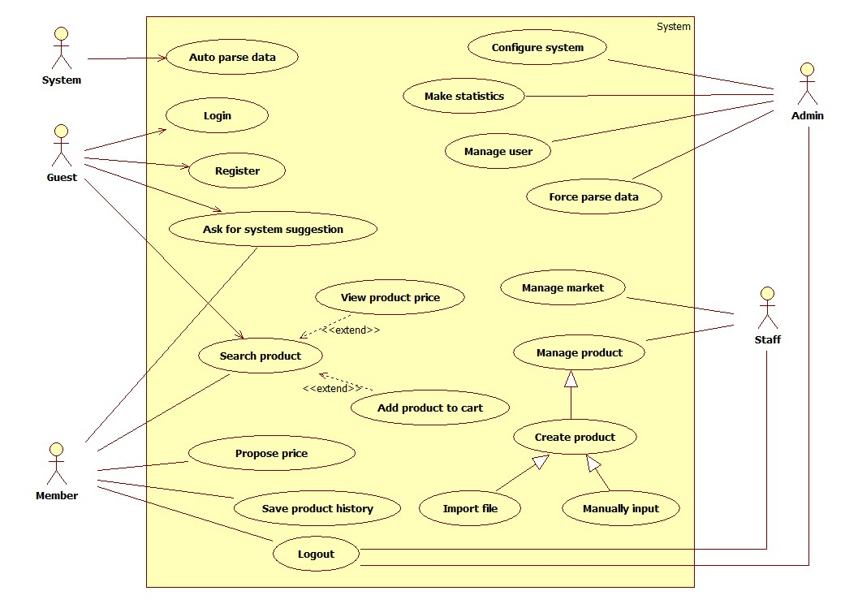

Figure 1: System Overview Use Case

### List of Use Case

#### <Admin> Overview Use Cases

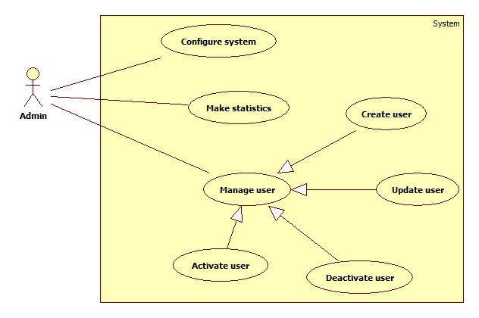

Figure 2: <Admin> Overview use case

##### <Admin> Configure System

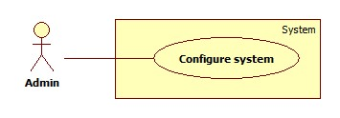

Figure 3: <Admin> Configure System

|  |  |  |  |
| --- | --- | --- | --- |
| **USE CASE – SB001** | | | |
| **Use Case No.** | SB001 | **Use Case Version** | 2.0 |
| **Use Case Name** | Configure system | | |
| **Author** | Doan Ho Anh Triet | | |
| **Date** | 15/02/2014 | **Priority** | High |
| **Actor:**   * Admin   **Summary:**   * This use case allows admin to configure the system.   **Goal:**   * System parameters will be configured by admin.   **Triggers:**   * Admin wants to change system parameter, such as epsilon number or parse time. * To go to “System Configuration” screen, admin clicks at “System configuration” menu.   **Preconditions:**   * User must log in the system with the admin role.   **Post Conditions:**   * **Success:** New parameter will be saved to configuration file. * **Fail:** Nothing is saved to configuration file.   **Main Success Scenario:**   |  |  |  | | --- | --- | --- | | Step | Actor Action | System Response | | 1 | Click at “System Configuration” link in the menu. | Show “System Configuration” page which contains:   * Epsilon: textbox, min length: 1, max length: 3, type: integer number, min value: 1, max value: 100, required. * Thời gian parse: time picker, min value: 0:00, max value: 23:59, required. * Lưu: button. | | 2 | Admin changes system parameters. |  | | 3 | Click on “Lưu” button.  [Exception 1, 2, 3] | * Save data to configuration file. * Show success message. |   **Alternative Scenario:** N/A  **Exceptions:**   |  |  |  | | --- | --- | --- | | No | Actor Action | System Response | | 1 | Epsilon value out of range. | Show error message: “Epsilon phải lớn hơn 0 và nhỏ hơn hoặc bằng 100!” | | 2 | Epsilon is not a number. | Show error message: “Epsilon phải là số!” | | 3 | Time format is not correct. | Show error message: “Thời gian phải đúng định dạng!” |   **Relationships:** N/A  **Business Rules:** N/A | | | |

Table 1: <Admin> Configure System

##### <Admin> Make Statistics

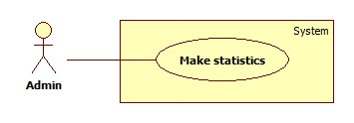

Figure 4: <Admin> Make Statistics

|  |  |  |  |
| --- | --- | --- | --- |
| **USE CASE – SB002** | | | |
| **Use Case No.** | SB002 | **Use Case Version** | 2.0 |
| **Use Case Name** | Make statistics | | |
| **Author** | Doan Ho Anh Triet | | |
| **Date** | 15/02/2014 | **Priority** | Normal |
| **Actor:** Admin  **Summary:**  **Goal:**  **Triggers:**  **Preconditions:**   * User must log in the system with admin role.   **Post Conditions:**   * **Success:** * **Fail:**   **Main Success Scenario:**   |  |  |  | | --- | --- | --- | | Step | Actor Action | System Response | | 1 |  |  |   **Alternative Scenario:**   |  |  |  | | --- | --- | --- | | No | Actor Action | System Response | | 1 |  |  |   **Exceptions:**   |  |  |  | | --- | --- | --- | | No | Actor Action | System Response | | 1 |  |  |   **Relationships:**  **Business Rules:** | | | |

Table 2: <Admin> Make Statistics

##### <Admin> Create User

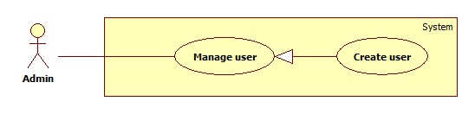

Figure 5: <Admin> Create User

|  |  |  |  |
| --- | --- | --- | --- |
| **USE CASE – SB003** | | | |
| **Use Case No.** | SB003 | **Use Case Version** | 2.0 |
| **Use Case Name** | Create user | | |
| **Author** | Doan Ho Anh Triet | | |
| **Date** | 15/02/2014 | **Priority** | Normal |
| **Actor:**   * Admin   **Summary:**   * This user case allows admin to create new user account for the system.   **Goal:**   * New user account will be added to the system.   **Triggers:**   * Admin wants to create new user account. * Navigate to “Quản lý tài khoản” and click “Tạo tài khoản” button.   **Preconditions:**   * User must log in the system with admin role.   **Post Conditions:**   * **Success:** New user account will be added to the database. * **Fail:** Nothing is added to the database.   **Main Success Scenario:**   |  |  |  | | --- | --- | --- | | Step | Actor Action | System Response | | 1 | Admin clicks “Tạo tài khoản” link. | Navigate to “Tạo tài khoản” page which contains:   * Username: textbox, min length: 6, max length: 30, required. * Password: textbox, min length: 6, max length: 20, required. * Role: drop down list, required. * Tạo tài khoản: button. * Xóa trắng: button. | | 2 | Admin fills data to the form. |  | | 3 | Admin clicks “Tạo tài khoản” button. [Alternative 1], [Exception 1, 2, 3, 4] | Insert new user account to the database and redirect to “Quản lý tài khoản” page. |   **Alternative Scenario:**   |  |  |  | | --- | --- | --- | | No | Actor Action | System Response | | 1 | Admin clicks “Xóa trắng button”. | Clear all input data. |   **Exceptions:**   |  |  |  | | --- | --- | --- | | No | Actor Action | System Response | | 1 | Length of username is not in range. | Show error message: “Độ dài username phải từ 6-30 ký tự!” | | 2 | Length of password is not in range. | Show error message: “Độ dài password phải từ 6-20 ký tự!” | | 3 | Role is not specified. | Show error message: “Phải phân quyền cho user!” | | 4 | Username’s existed already. | Show error message: “Trùng tên đăng nhập! Vui lòng chọn tên khác!” |   **Relationships:** Manage user  **Business Rules:**   * Each created account must be in active state when insert to database. | | | |

Table 3: <Admin> Create User

##### <Admin> Update User

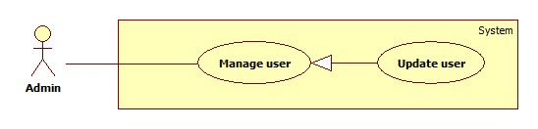

Figure 6: <Admin> Update User

|  |  |  |  |
| --- | --- | --- | --- |
| **USE CASE – SB004** | | | |
| **Use Case No.** | SB004 | **Use Case Version** | 2.0 |
| **Use Case Name** | Update user | | |
| **Author** | Doan Ho Anh Triet | | |
| **Date** | 16/02/2014 | **Priority** | Normal |
| **Actor:**   * Admin   **Summary:**   * This use case allows admin to update information for user accounts.   **Goal:**   * New information will be updated to the database.   **Triggers:**   * Admin wants to change some information of members or staffs.   **Preconditions:**   * User must log in system with admin role.   **Post Conditions:**   * **Success:** New information will be updated to the database. * **Fail:** Nothing is updated.   **Main Success Scenario:**   |  |  |  | | --- | --- | --- | | Step | Actor Action | System Response | | 1 | Click menu item “Quản lý tài khoản”. | Navigate to “Quản lý tài khoản” page which contains:   * A table with 4 columns:   + Số thứ tự.   + Tên đăng nhập.   + Trạng thái.   + Hành động. * Tạo tài khoản: button. | | 2 | Click at username. | Navigate to “Thông tin tài khoản” page, which contains:   * Username: textbox, min length: 6, max length: 30, disabled. * Password: textbox, min length: 6, max length: 20, required. * Email: textbox, min length: 0, max length: 100, regular expression: ^[a-zA-Z0-9.!#$%&'*+/=?^_`{|}~-]+@[a-zA-Z0-9](?:[a-zA-Z0-9-]{0,61}[a-zA-Z0-9])?(?:\.[a-zA-Z0-9](?:[a-zA-Z0-9-]{0,61}[a-zA-Z0-9])?)*$, required. * Role: drop down list, required. * Cập nhật: button. | | 3 | Admin updates information. |  | | 4 | Click “Cập nhật” button. | New information will be updated to the database. |   **Alternative Scenario:** N/A  **Exceptions:**   |  |  |  | | --- | --- | --- | | No | Actor Action | System Response | | 1 | Length of password is not in range. | Show error message: “Độ dài password phải từ 6-20 ký tự!” | | 2 | Role is not specified. | Show error message: “Phải phân quyền cho user!” | | 3 | Invalid email format. | Show error message: “Email phải đúng định dạng!” |   **Relationships:** Manage User  **Business Rules:**   * Editing username is forbidden. | | | |

Table 4: <Admin> Update User

##### <Admin> Activate User

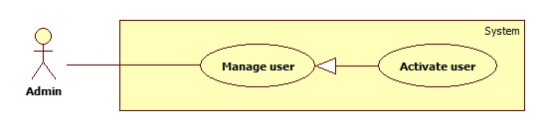

Figure 7: <Admin> Active User

|  |  |  |  |
| --- | --- | --- | --- |
| **USE CASE – SB005** | | | |
| **Use Case No.** | SB005 | **Use Case Version** | 2.0 |
| **Use Case Name** | Activate User | | |
| **Author** | Doan Ho Anh Triet | | |
| **Date** | 16/02/2014 | **Priority** | Normal |
| **Actor:**   * Admin   **Summary:**   * This user case allows admin to activate a user account.   **Goal:**   * Deactivated accounts will be activated again.   **Triggers:**   * Admin wants to activate an account so that it can be used to log in the system again.   **Preconditions:**   * User must log in the system with admin role.   **Post Conditions:**   * **Success:** The selected account will be activated. * **Fail:** No account is activated.   **Main Success Scenario:**   |  |  |  | | --- | --- | --- | | Step | Actor Action | System Response | | 1 | Click menu item “Quản lý tài khoản”. | Navigate to “Quản lý tài khoản” page which contains:   * A table with 4 column:   + Số thứ tự.   + Tên đăng nhập.   + Trạng thái. * Tạo tài khoản: button. | | 2 | Check the checkbox in “Trạng thái” cell of a deactivated account. | Selected account is activated again. [Exception 1] |   **Alternative Scenario:** N/A  **Exceptions:**   |  |  |  | | --- | --- | --- | | No | Actor Action | System Response | | 1 | Cannot activate the account due to database connection. | Show error message: “Không thể kích hoạt! Vui lòng thử lại sau.” |   **Relationships:** Manage User  **Business Rules:**   * Admins can’t activate/deactivate account of themselves or other admins. | | | |

Table 5: <Admin> Activate User

##### <Admin> Deactivate User

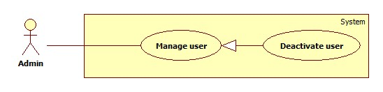

Figure 8: <Admin> Deactivate User

|  |  |  |  |
| --- | --- | --- | --- |
| **USE CASE – SB006** | | | |
| **Use Case No.** | SB006 | **Use Case Version** | 2.0 |
| **Use Case Name** | Deactivate User | | |
| **Author** | Doan Ho Anh Triet | | |
| **Date** | 16/02/2014 | **Priority** | Normal |
| **Actor:**   * Admin   **Summary:**   * This user case allows admin to deactivate an account.   **Goal:**   * An active account will be deactivated.   **Triggers:**   * In our system, when we do not want a user to login, we deactivate his/her account. That account can be activated later.   **Preconditions:**   * User must log in the system with admin role.   **Post Conditions:**   * **Success:** The selected account will be deactivated. * **Fail:** No account is deactivated.   **Main Success Scenario:**   |  |  |  | | --- | --- | --- | | Step | Actor Action | System Response | | 1 | Click menu item “Quản lý tài khoản”. | Navigate to “Quản lý tài khoản” page which contains:   * A table with 4 column:   + Số thứ tự.   + Tên đăng nhập.   + Trạng thái. * Tạo tài khoản: button. | | 2 | Uncheck the checkbox in “Trạng thái” cell of an active account. | The selected account will be deactivated.  [Exception 1] |   **Alternative Scenario:** N/A  **Exceptions:**   |  |  |  | | --- | --- | --- | | No | Actor Action | System Response | | 1 | Cannot deactivate the account due to database connection. | Show error message: “Không thể kích hoạt! Vui lòng thử lại sau.” |   **Relationships:** Manage Account  **Business Rules:**   * Admins can’t activate/deactivate account of themselves or other admins. | | | |

Table 6: <Admin> Deactivate User

##### <Admin> Force Parse Data

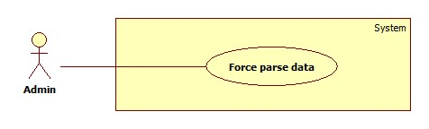

Figure 9: <Admin> Force Parse Data

|  |  |  |  |
| --- | --- | --- | --- |
| **USE CASE – SB007** | | | |
| **Use Case No.** | SB007 | **Use Case Version** | 2.0 |
| **Use Case Name** | Force Parse Data | | |
| **Author** | Doan Ho Anh Triet | | |
| **Date** | 16/02/2014 | **Priority** | High |
| **Actor:**   * Admin.   **Summary:**   * Admin can force system to parse data at any time.   **Goal:**   * Get data from many websites.   **Triggers:**   * Admin wants to run the parser at that time. * Admin clicks “Parse” button.   **Preconditions:**   * User logged in with “Admin” role.   **Post Conditions:**   * **Success:** New data is inserted to database. Log file is generated. * **Fail:** Nothing is changed in the database. Log file is generated.   **Main Success Scenario:**   |  |  |  | | --- | --- | --- | | Step | Actor Action | System Response | | 1 | Staff clicks “Parse” button. | * Disable “Parse” button. Change its text into “Parsing…” * Send request to the parsed link. * Fetch data from the response based on the inputted XPaths. * Validate data [Exception 1]. * If data is valid, insert to database [Alternative 1]. * Generate log file. * Enable “Parse” button. Change its text into “Parse”. |   **Alternative Scenario:**   |  |  |  | | --- | --- | --- | | Step | Actor Action | System Response | | 1 | Staff clicks “Parse” button. | * If fetched product is already in the database, update its information. * Generate log file. |   **Exceptions:**   |  |  |  | | --- | --- | --- | | No | Actor Action | System Response | | 1 | Data is not valid. | * Don’t insert to database. * Generate log file. |   **Relationships:** N/A  **Business Rules:**   * Refer to “Auto Parse Data” use case. | | | |

Table 7: <Admin> Force Parse Data

#### <System> Overview Use Case

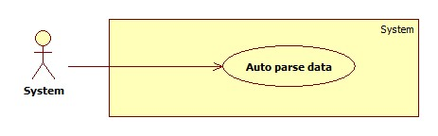

Figure 10: <System> Overview Use Case

##### <System> Auto Parse Data



Figure 11: <System> Auto Parse Data

|  |  |  |  |
| --- | --- | --- | --- |
| **USE CASE – SB008** | | | |
| **Use Case No.** | SB008 | **Use Case Version** | 2.0 |
| **Use Case Name** | Auto Parse Data | | |
| **Author** | Doan Ho Anh Triet | | |
| **Date** | 16/02/2014 | **Priority** | High |
| **Actor:**   * System.   **Summary:**   * System can parse data automatically from many websites at specified time.   **Goal:**   * Get data from many websites.   **Triggers:**   * The time hits configured time.   **Preconditions:**   * Parse time has been configured.   **Post Conditions:**   * **Success:** New data is inserted to database. Log file is generated. * **Fail:** Nothing is changed in the database. Log file is generated.   **Main Success Scenario:**   |  |  |  | | --- | --- | --- | | Step | Actor Action | System Response | | 1 | Server checks the current time. If it hits configured time, parse process starts. | * Send request to the parsed link. * Fetch data from the response based on the inputted XPaths. * Validate data [Exception 1]. * If data is valid, insert to database [Alternative 1]. * Generate log file. |   **Alternative Scenario:**   |  |  |  | | --- | --- | --- | | Step | Actor Action | System Response | | 1 | Server checks the current time. If it hits configured time, parse process starts. | * If fetched product is already in the database, update its information. * Generate log file. |   **Exceptions:**   |  |  |  | | --- | --- | --- | | No | Actor Action | System Response | | 1 | Data is invalid. | * Don’t insert to database. * Generate log file. |   **Relationships:** N/A  **Business Rules:**   * If price is negative or not a number, consider it invalid. * Log file structure:   SMART BUY LOG FILE  Tạo file lúc: {Created date}, {Created time}   |  |  |  |  |  |  |  | | --- | --- | --- | --- | --- | --- | --- | | STT | Link | Thời gian parse | Dạng dữ liệu | Tổng sản phẩm | Insert thành công | Insert thất bại | |  |  |  |  |  |  |  | |  |  |  |  |  |  |  |   Tổng thời gian parse dạng {Data type}: {Elapsed time}  Tổng thời gian parse: {Total elapsed time}  Tổng sản phẩm parse được: {Total parsed product} | | | |

Table 8: <System> Auto Parse Data

#### <Staff >Overview Use Case

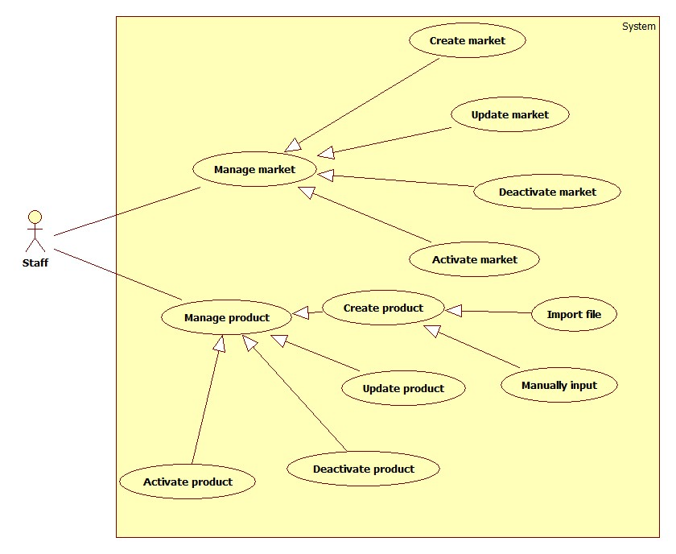

Figure 12: <Staff> Overview Use Case

##### <Staff> Create Market

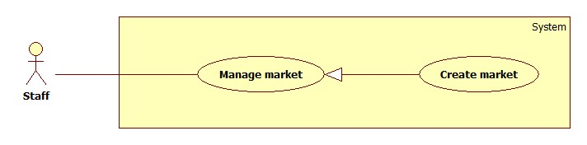

Figure 13: <Staff> Create Market

|  |  |  |  |
| --- | --- | --- | --- |
| **USE CASE – SB009** | | | |
| **Use Case No.** | SB009 | **Use Case Version** | 2.0 |
| **Use Case Name** | Create Market | | |
| **Author** | Doan Ho Anh Triet | | |
| **Date** | 19/02/2014 | **Priority** | Normal |
| **Actor:**   * Staff.   **Summary:**   * This use case allows staff to create a new market.   **Goal:**   * A new market added to the database.   **Triggers:**   * Staff wants to create a new market. * To create new market, staff must do the following steps:   + Click “Quản lý chợ” on the menu.   + Click “Tạo chợ mới” button.   **Preconditions:**   * User must log in the system with staff role.   **Post Conditions:**   * **Success**: New market will be added to the database. * **Fail:** Nothing is added to the database. Show error message.   **Main Success Scenario:**   |  |  |  | | --- | --- | --- | | Step | Actor Action | System Response | | 1 | Click “Quản lý chợ” in menu bar. | Navigate to “Quản lý chợ” page which contains:   * A table has 4 columns:   + Số thứ tự   + Tên chợ   + Địa chỉ   + Trạng thái * Tạo chợ mới: button | | 2 | Click “Tạo chợ mới” button. | Navigate to “Tạo chợ mới” page, which contains:   * Tên chợ: textbox, min length: 6, max length: 50, required. * Địa chỉ: textbox, min length: 6, max length: 100. * Vĩ độ: textbox, decimal number only, min value: -90, max value: 90, min length: 1, max length: 10 * Kinh độ: textbox, decimal number only, min value: -180, max value: 180, min lengh: 1, max length: 11. * Tạo mới: button * Xóa trắng: button | | 3 | Input market information, click “Tạo mới” button. [Alternative 1] | Add new market to the database. Redirect to “Quản lý chợ” page.  [Exception 1, 2, 3, 4, 5, 6, 7, 8, 9] |   **Alternative Scenario:**   |  |  |  | | --- | --- | --- | | Step | Actor Action | System Response | | 1 | Click “Xóa trắng” button | Clear all input fields. |   **Exceptions:**   |  |  |  | | --- | --- | --- | | No | Actor Action | System Response | | 1 | Duplicate “Tên chợ”. | Show error message: “Tên này đã có trong hệ thống. Vui lòng chọn tên khác!” | | 2 | Length of “Tên chợ” is not in range. | Show error message: “Tên chợ phải từ 6 đến 50 ký tự!” | | 3 | Length of “Địa chỉ” is not in range. | Show error message: “Địa chỉ phải từ 6 đến 100 ký tự!” | | 4 | “Vĩ độ” is not a number. | Show error message: “Vĩ độ phải là số!” | | 5 | Length of “Vĩ độ” is not in range. | Show error message: “Vĩ độ có độ dài từ 1 đến 10 ký tự!” | | 6 | Value of “Vĩ độ” is not in range. | Show error message: “Giá trị của vĩ độ phải từ 0 đến 90!” | | 7 | “Kinh độ” is not a number. | Show error message: “Kinh độ phải là số!” | | 8 | Length of “Kinh độ” is not in range. | Show error message: “Kinh độ có độ dài từ 1 đến 11 ký tự!” | | 9 | Value of “Kinh độ” is not in range. | Show error message: “Giá trị của kinh độ phải từ -180 đến 180!” |   **Relationships:** Manage market.  **Business Rules:**   * We should apply Google Map auto complete to “Địa chỉ” textbox. * User can only input “Địa chỉ” or “Vĩ độ”, “Kinh độ” pair, not both. | | | |

Table 9: <Staff> Create Market

##### <Staff> Update Market

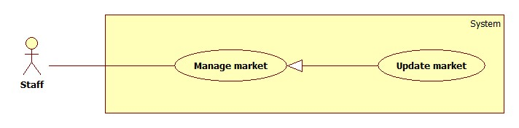

Figure 14: <Staff> Update Market

|  |  |  |  |
| --- | --- | --- | --- |
| **USE CASE – SB010** | | | |
| **Use Case No.** | SB010 | **Use Case Version** | 2.0 |
| **Use Case Name** | Update Market | | |
| **Author** | Doan Ho Anh Triet | | |
| **Date** | 19/02/2014 | **Priority** | Normal |
| **Actor:**   * Staff.   **Summary:**   * This use case allows staff to update market information.   **Goal:**   * Update new information to the market.   **Triggers:**   * Staff wants to update information of markets. * To update information of markets, staff must do the following steps:   + Click “Quản lý chợ” in the menu.   + Click at the name of the market which staff wants to change information.   **Preconditions:**   * User must log in the system with staff role.   **Post Conditions:**   * **Success**: Market information will be updated. * **Fail:** Nothing is updated. Show error message.   **Main Success Scenario:**   |  |  |  | | --- | --- | --- | | Step | Actor Action | System Response | | 1 | Click “Quản lý chợ” in menu bar. | Navigate to “Quản lý chợ” page which contains:   * A table has 4 columns:   + Số thứ tự   + Tên chợ   + Địa chỉ   + Trạng thái * Tạo chợ mới: button | | 2 | Click at the market name. | Navigate to “Thông tin chợ” page, which contains:   * Tên chợ: textbox, min length: 6, max length: 50, required. * Địa chỉ: textbox, min length: 6, max length: 100. * Vĩ độ: textbox, decimal number only, min value: -90, max value: 90, min length: 1, max length: 10 * Kinh độ: textbox, decimal number only, min value: -180, max value: 180, min lengh: 1, max length: 11. * Cập nhật: button | | 3 | Edit market information, click “Cập nhật” button. | The system will update new market information to the database. Redirect to “Quản lý chợ” page.  [Exception 1, 2, 3, 4, 5, 6, 7, 8, 9] |   **Alternative Scenario:** N/A  **Exceptions:**   |  |  |  | | --- | --- | --- | | No | Actor Action | System Response | | 1 | Duplicate “Tên chợ”. | Show error message: “Tên này đã có trong hệ thống. Vui lòng chọn tên khác!” | | 2 | Length of “Tên chợ” is not in range. | Show error message: “Tên chợ phải từ 6 đến 50 ký tự!” | | 3 | Length of “Địa chỉ” is not in range. | Show error message: “Địa chỉ phải từ 6 đến 100 ký tự!” | | 4 | “Vĩ độ” is not a number. | Show error message: “Vĩ độ phải là số!” | | 5 | Length of “Vĩ độ” is not in range. | Show error message: “Vĩ độ có độ dài từ 1 đến 10 ký tự!” | | 6 | Value of “Vĩ độ” is not in range. | Show error message: “Giá trị của vĩ độ phải từ 0 đến 90!” | | 7 | “Kinh độ” is not a number. | Show error message: “Kinh độ phải là số!” | | 8 | Length of “Kinh độ” is not in range. | Show error message: “Kinh độ có độ dài từ 1 đến 11 ký tự!” | | 9 | Value of “Kinh độ” is not in range. | Show error message: “Giá trị của kinh độ phải từ -180 đến 180!” |   **Relationships:** Manage market.  **Business Rules:**   * We should apply Google Map auto complete to “Địa chỉ” textbox. * User can only input “Địa chỉ” or “Vĩ độ”, “Kinh độ” pair, not both. | | | |

Table 10: <Staff> Update Market

##### <Staff> Deactivate Market

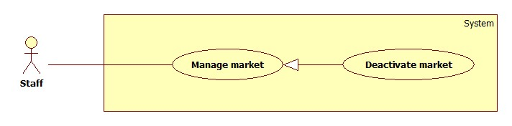

Figure 15: <Staff> Deactivate Market

|  |  |  |  |
| --- | --- | --- | --- |
| **USE CASE – SB011** | | | |
| **Use Case No.** | SU011 | **Use Case Version** | 2.0 |
| **Use Case Name** | Deactivate Market | | |
| **Author** | Doan Ho Anh Triet | | |
| **Date** | 20/02/2014 | **Priority** | Normal |
| **Actor:**   * Staff.   **Summary:**   * This use case allows staff to deactivate market in the system.   **Goal:**   * Markets will be deactivated.   **Triggers:**   * Staff wants to deactivate a market so that it is no longer available in the system. * To deactivate a market, staff must do the following steps:   + Click “Quản lý chợ” item in the menu.   + Uncheck the status checkbox of each active market.   **Preconditions:**   * User must log in the system with staff role.   **Post Conditions:**   * **Success**: The selected market will be deactivated. * **Fail:** Nothing is changed. Show error message.   **Main Success Scenario:**   |  |  |  | | --- | --- | --- | | Step | Actor Action | System Response | | 1 | Click “Quản lý chợ” in menu bar. | Navigate to “Quản lý chợ” page which contains:   * A table has 4 columns:   + Số thứ tự   + Tên chợ   + Địa chỉ   + Trạng thái   Tạo chợ mới: button | | 2 | Uncheck the checkbox in “Trạng thái” cell of an active market. | The selected market will be deactivated. [Exception 1]  Show success message: “Thao tác thành công!” |   **Alternative Scenario:** N/A  **Exceptions:**   |  |  |  | | --- | --- | --- | | Step | Actor Action | System Response | | 1 | Cannot deactivate the market due to database connection problem. | Show error message: “Thao tác không thể thực hiện. Vui lòng thử lại sau!” |   **Relationships:** Manage Market.  **Business Rules:**   * Cannot deactivate virtual market. | | | |

Table 11: <Staff> Deactivate Market

##### <Staff> Activate Market

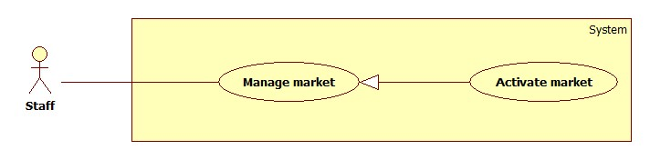

Figure 16: <Staff> Activate Market

|  |  |  |  |
| --- | --- | --- | --- |
| **USE CASE – SB012** | | | |
| **Use Case No.** | SB012 | **Use Case Version** | 2.0 |
| **Use Case Name** | Activate Market | | |
| **Author** | Doan Ho Anh Triet | | |
| **Date** | 20/02/2014 | **Priority** | Normal |
| **Actor:**   * Staff.   **Summary:**   * This use case allows staff to activate the market.   **Goal:**   * Selected market will be activated.   **Triggers:**   * Staff wants to activate a market so that it can be accessed from the system again. * To activate the market, staff must do the following steps:   + Click “Quản lý chợ” item in the menu.   + Check the status checkbox of each deactivated market   **Preconditions:**   * User must log in the system with staff role.   **Post Conditions:**   * **Success**: Market will be activated again. * **Fail:** Nothing is changed. Show error message.   **Main Success Scenario:**   |  |  |  | | --- | --- | --- | | Step | Actor Action | System Response | | 1 | Click “Quản lý chợ” in menu bar. | Navigate to “Quản lý chợ” page which contains:   * A table has 4 columns:   + Số thứ tự   + Tên chợ   + Địa chỉ   + Trạng thái   Tạo chợ mới: button | | 2 | Check the checkbox in “Trạng thái” cell of an deactivated market. | The selected market will be deactivated. [Exception 1]  Show success message: “Thao tác thành công!” |   **Alternative Scenario:** N/A  **Exceptions:**   |  |  |  | | --- | --- | --- | | Step | Actor Action | System Response | | 1 | Cannot activate the market due to database connection problem. | Show error message: “Thao tác không thể thực hiện. Vui lòng thử lại sau!” |   **Relationships:** Manage Market.  **Business Rules:** N/A | | | |

Table 12: <Staff> Activate Market

##### <Staff> Import File

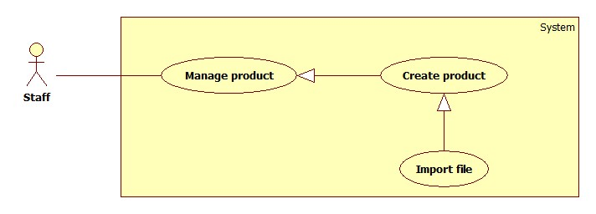

Figure 17: <Staff> Import File

|  |  |  |  |
| --- | --- | --- | --- |
| **USE CASE – SB013** | | | |
| **Use Case No.** | SB013 | **Use Case Version** | 2.0 |
| **Use Case Name** | Import File | | |
| **Author** | Tran Trung Dung | | |
| **Date** | 20/02/2014 | **Priority** | High |
| **Actor:**   * Staff   **Summary:**   * This use case allows staff to import data from excel files.   **Goal:**   * Create many products from imported files.   **Triggers:**   * Staff wants to create many products by importing excel files. * To import a file, staff must do the following steps:   + Click “Nhập từ excel” menu.   + Choose the file, click “Tải lên” button.   **Preconditions:**   * User must log in the system with staff role.   **Post Conditions:**   * **Success**: Products will be added to the database. Show success message. * **Fail:** Nothing is saved to the database. Show error list.   **Main Success Scenario:**   |  |  |  | | --- | --- | --- | | Step | Actor Action | System Response | | 1 | From the staff’s page, staff clicks “Nhập từ Excel” link. | Show “Nhập từ excel” page with 2 buttons:   * “Chọn file” button. * “Tải lên” button. | | 2 | From “Nhập từ excel” page, staff clicks “Chọn file” button, then clicks “Mở”. | System will get file path and show on text box. | | 3 | Staff clicks “Tải lên” button | File is uploaded to server, then redirect back to “Nhập từ excel” page, contains:   * A 4-columns table show detail of product in excel file. Column header includes:   + “STT” label.   + “Tên sản phẩm” label.   + “Tên chợ” label.   + “Giá (Ngàn đồng)” label. * “Lưu” button. * “Hủy” button.   [Exception 1, 2, 3, 4] | | 5 | Staff clicks “Lưu” button to save product. [Alternative 1] | Save products to database. [Exception 5] |   **Alternative Scenario:**   |  |  |  | | --- | --- | --- | | Step | Actor Action | System Response | | 1 | Click on “Hủy” button to finish. | No product is added. System will return back to “Nhập từ excel” page. |   **Exceptions:**   |  |  |  | | --- | --- | --- | | Step | Actor Action | System Response | | 1 | Product input is wrong format | Display error message: “File không đúng định dạng”. | | 2 | Product name is not in range [5, 20]. | Display error message: “Tên sản phẩm phải từ 5 đến 20 ký tự”. | | 3 | Market name is not in range [5, 20]. | Display error message: “Tên chợ phải từ 5 đến 20 ký tự”. | | 4 | Price is not in range [1, 10000]. | Display error message: “Giá sản phẩm phải từ 1 đến 10000”. | | 5 | Fail to insert to database. | Display error message: “Có lỗi xảy ra. Vui lòng thử lại sau”. |   **Relationships:** Manage Product, Create Product.  **Business Rules:**   * Valid file format :      * Format file is excel (.xlsx) * File has less than 5 errors. * File has more than 5 errors. Display list error rows. | | | |

Table 13: <Staff> Import File

##### <Staff> Manually Input

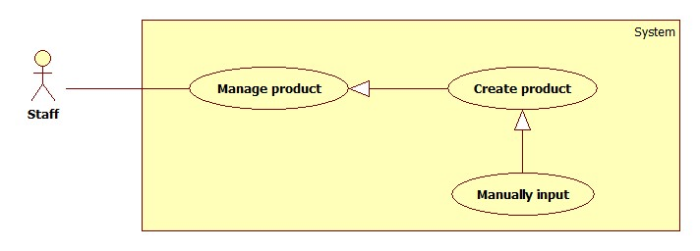

Figure 18: <Staff> Manually Input

|  |  |  |  |
| --- | --- | --- | --- |
| **USE CASE – SB014** | | | |
| **Use Case No.** | SB014 | **Use Case Version** | 2.0 |
| **Use Case Name** | Manually Input | | |
| **Author** | Tran Trung Dung | | |
| **Date** | 20/02/2014 | **Priority** | High |
| **Actor:**   * Staff.   **Summary:**   * This use case allows staff to input product manually.   **Goal:**   * New product will be added to the database.   **Triggers:**   * Staff wants to input new product manually. * To input product manually, staff must do the following steps:   + Click “Quản lý sản phẩm” in the menu.   + Click “Tạo sản phẩm” button.   **Preconditions:**   * User must log in the system with staff role.   **Post Conditions:**   * **Success**: New product will be added to the database. * **Fail:** Nothing is added to the database. Show error message.   **Main Success Scenario:**   |  |  |  | | --- | --- | --- | | Step | Actor Action | System Response | | 1 | Click “Tạo sản phẩm” button. | Navigate to “Tạo sản phẩm” page which contains:   * Tên sản phẩm: textbox (min length: 5, max length: 20), required. * Tên chợ: drop down list, list of available markets in the system, required. * Giá: textbox (min value: 1, max value: 10000, integer number only, min length: 1, max length: 5), required. * “Thêm sản phẩm” button. * “Hủy” button. | | 2 | Enter information into text fields.  Click “Thêm sản phẩm” button to finish. [Alternative 1] | System will add product to database.  A new product will be displayed in list product page. Then, redirect to list product page. [Exception 1, 2, 3] |   **Alternative Scenario:**   |  |  |  | | --- | --- | --- | | Step | Actor Action | System Response | | 1 | Click on “Hủy” button to finish. | No product is added. System will return back to list product page. |   **Exceptions:**   |  |  |  | | --- | --- | --- | | Step | Actor Action | System Response | | 1 | “Tên sản phẩm” is not in range [5, 20]. | Display error message: “Tên sản phẩm phải từ 5 đến 20 ký tự”. | | 2 | “Tên chợ” is not selected. | Display error message: “Phải chọn chợ”. | | 3 | “Giá” is not in range [1, 10000]. | Display error message: “Giá sản phẩm phải từ 1 đến 10000”. |   **Relationships:** Manage Product, Create Product.  **Business Rules:**   * When staff enters product name, system will search all product name in the database. * Staff can choose existed product and update the price of this product. | | | |

Table 14: <Staff> Manually Input

##### <Staff> Update Product

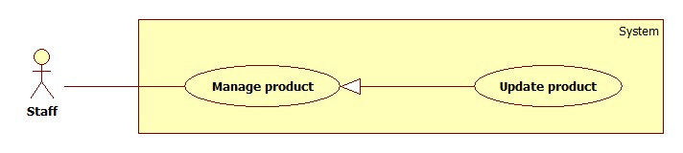

Figure 19: <Staff> Update Product

|  |  |  |  |
| --- | --- | --- | --- |
| **USE CASE – SB015** | | | |
| **Use Case No.** | SB015 | **Use Case Version** | 2.0 |
| **Use Case Name** | Update Product | | |
| **Author** | Doan Ho Anh Triet | | |
| **Date** | 20/02/2014 | **Priority** | Normal |
| **Actor:**   * Staff.   **Summary:**   * This use case allows staff to update product information.   **Goal:**   * New information will be updated to selected product.   **Triggers:**   * Staff wants to change product information. * To change product information, staff must do the following steps:   + Click “Quản lý sản phẩm” in menu bar.   + Click at product name.   + Change information.   + Click “Cập nhật” button to save new data to database.   **Preconditions:**   * User must log in the system with staff role. * There is at least one product in the database.   **Post Conditions:**   * **Success**: New information will be updated to selected product. * **Fail:** Nothing is updated. Show error message.   **Main Success Scenario:**   |  |  |  | | --- | --- | --- | | Step | Actor Action | System Response | | 1 | Click “Quản lý sản phẩm” in menu bar. | Navigate to “Quản lý sản phẩm” page which contains:   * A table has 5 columns:   + Số thứ tự.   + Tên sản phẩm.   + Khoảng giá.   + Thời gian cập nhật.   + Trạng thái | | 2 | Click at any product name. | Navigate to “Thông tin sản phẩm” page which contains:   * Tên sản phẩm: textbox, min length: 5, max length: 20, required. * Tên chợ: drop down list, list of available markets in the system, required. * Giá: textbox, integer number only, min value: 1, max value: 10000, min length: 1, max length: 5, required. * Cập nhật: button. | | 3 | Update new data. Click “Cập nhật” button. | Save new data to the database. Redirect to “Quản lý sản phẩm” page. |   **Alternative Scenario:** N/A  **Exceptions:**   |  |  |  | | --- | --- | --- | | Step | Actor Action | System Response | | 1 | “Tên sản phẩm” is not in range [5, 20]. | Display error message: “Tên sản phẩm phải từ 5 đến 20 ký tự”. | | 2 | “Tên chợ” is not selected. | Display error message: “Phải chọn chợ”. | | 3 | “Giá” is not in range [1, 10000]. | Display error message: “Giá sản phẩm phải từ 1 đến 10000”. |   **Relationships:** Manage Product.  **Business Rules:** N/A | | | |

Table 15: <Staff> Update Product

##### <Staff> Deactivate Product

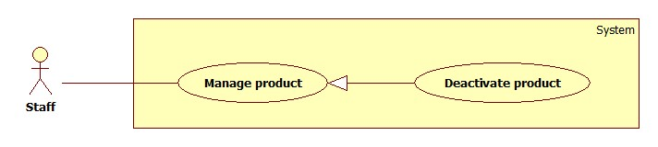

Figure 20: <Staff> Deactivate Product

|  |  |  |  |
| --- | --- | --- | --- |
| **USE CASE – SB016** | | | |
| **Use Case No.** | SB016 | **Use Case Version** | 2.0 |
| **Use Case Name** | Deactivate Product | | |
| **Author** | Doan Ho Anh Triet | | |
| **Date** | 20/02/2014 | **Priority** | Normal |
| **Actor:**   * Staff.   **Summary:**   * This use case allows staff to deactivate product.   **Goal:**   * Selected product will be deactivated.   **Triggers:**   * Staff wants to deactivate a product in the system. * To deactivate a product, staff must do the following steps:   + Click “Quản lý sản phẩm” in menu bar.   + Uncheck any active product.   **Preconditions:**   * User must log in the system with staff role.   **Post Conditions:**   * **Success**: Selected product will be deactivated. * **Fail:** Nothing is changed. Show error message.   **Main Success Scenario:**   |  |  |  | | --- | --- | --- | | Step | Actor Action | System Response | | 1 | Click “Quản lý sản phẩm” in menu bar. | Navigate to “Quản lý sản phẩm” page which contains:   * A table has 5 columns:   + Số thứ tự.   + Tên sản phẩm.   + Khoảng giá.   + Thời gian cập nhật.   + Trạng thái | | 2 | Uncheck any active product. | Deactivate selected product. Show success message.  [Exception 1] |   **Alternative Scenario:** N/A  **Exceptions:**   |  |  |  | | --- | --- | --- | | No | Actor Action | System Response | | 1 | Cannot deactivate product due to database connection problem | Show error message: “Thao tác thất bại. Vui lòng thử lại sau!” |   **Relationships:** Manage Product.  **Business Rules:** N/A | | | |

Table 16: <Staff> Deactivate Product

##### <Staff> Activate Product

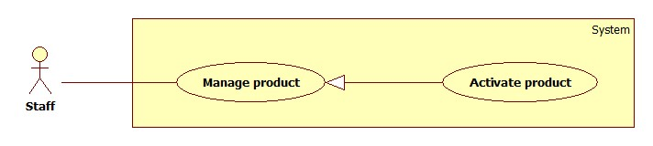

Figure 21: <Staff> Activate Product

|  |  |  |  |
| --- | --- | --- | --- |
| **USE CASE – SB017** | | | |
| **Use Case No.** | SB017 | **Use Case Version** | 2.0 |
| **Use Case Name** | Activate Product | | |
| **Author** | Doan Ho Anh Triet | | |
| **Date** | 20/02/2014 | **Priority** | Normal |
| **Actor:**   * Staff.   **Summary:**   * This use case allows staff to activate product.   **Goal:**   * Selected product will be activated.   **Triggers:**   * Staff wants to activate a product in the system. * To deactivate a product, staff must do the following steps:   + Click “Quản lý sản phẩm” in menu bar.   + Check any deactived product.   **Preconditions:**   * User must log in the system with staff role.   **Post Conditions:**   * **Success**: Selected product will be activated. * **Fail:** Nothing is changed. Show error message.   **Main Success Scenario:**   |  |  |  | | --- | --- | --- | | Step | Actor Action | System Response | | 1 | Click “Quản lý sản phẩm” in menu bar. | Navigate to “Quản lý sản phẩm” page which contains:   * A table has 5 columns:   + Số thứ tự.   + Tên sản phẩm.   + Khoảng giá.   + Thời gian cập nhật.   + Trạng thái | | 2 | Check any deactived product. | Activate selected product. Show success message.  [Exception 1] |   **Alternative Scenario:** N/A  **Exceptions:**   |  |  |  | | --- | --- | --- | | No | Actor Action | System Response | | 1 | Cannot activate product due to database connection problem | Show error message: “Thao tác thất bại. Vui lòng thử lại sau!” |   **Relationships:** Manage Product.  **Business Rules:** N/A | | | |

Table 17: <Staff> Activate Product

#### < Member> Overview Use Case

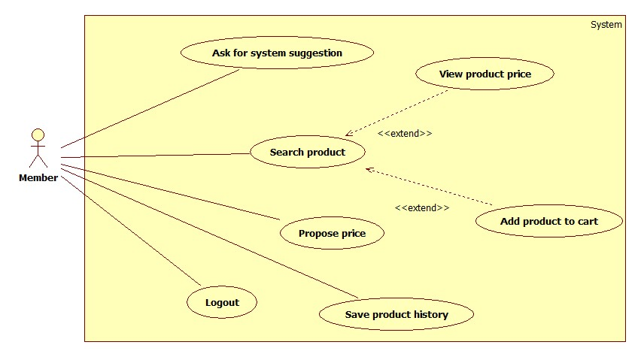

Figure 22: <Member> Overview Use Case

##### <Member> Ask For System Suggestion

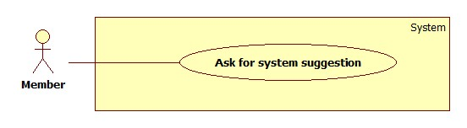

Figure 23: <Instructor> Ask For System Suggestion

|  |  |  |  |
| --- | --- | --- | --- |
| **USE CASE – SB018** | | | |
| **Use Case No.** | SB018 | **Use Case Version** | 2.0 |
| **Use Case Name** | Ask For System Suggestion | | |
| **Author** | Huynh Thanh Viet | | |
| **Date** | 20/02/2014 | **Priority** | High |
| **Actor:**   * Member.   **Summary:**   * Member can ask for system suggestion about how to buy a list of products.   **Goal:**   * Suggest user the place and things should buy.   **Triggers:**   * After user added a list of product, they can ask to have a suggestion which will be the best buying way. * User clicks “Gợi ý” button.   **Preconditions:**   * User must log in the system with member role. * User has defined a route.   **Post Conditions:**   * **Success**: Application will show all markets suitable for buying product. * **Fail:** Show an error message.   **Main Success Scenario:**   |  |  |  | | --- | --- | --- | | Step | Actor Action | System Response | | 1 | User click “Gợi ý” button. | * System will show a map with a suggest route as red line follow the street. * On that line will have many markers which each of them will representation for a place to buy. [Alternative 1] |   **Alternative Scenario:**   |  |  |  | | --- | --- | --- | | Step | Actor Action | System Response | | 1 | Search not found. | System will show a message: “Không tìm thấy”. |   **Exceptions:** N/A  **Relationships:** Add to cart  **Business Rules:**   * System finds market’s location dependence on the route which user defined. * If a product available on many markets, pick the market which has the lowest product’s price. | | | |

Table 18: <Member> Ask For System Suggestion

##### <Member> Search Product and View Product Price

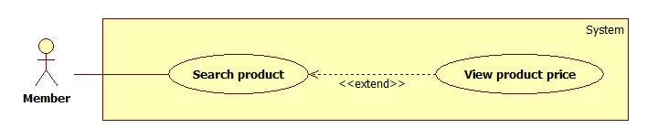

Figure 24: <Member> Search Product and View Product Price

|  |  |  |  |
| --- | --- | --- | --- |
| **USE CASE – SB019** | | | |
| **Use Case No.** | SB019 | **Use Case Version** | 2.0 |
| **Use Case Name** | Search Product and View Product Price | | |
| **Author** | Huynh Thanh Viet | | |
| **Date** | 20/02/2014 | **Priority** | High |
| **Actor:**   * Member. * Guest.   **Summary:**   * This use case allows user to search and view product information.   **Goal:**   * A list of products will be shown to user.   **Triggers:**   * User can search product to get product’s information: name, range of price. * In search screen, user inputs name of product then they search all products with relative name which they inputted. The searching results will show a list of product which follow product name. * User inputs to a blank textbox then clicks “Tìm” button.   **Preconditions:**   * For mobile application:   + Mobile connected to a wireless network or active data connection (2G, 3G).   + In case the internet connection isn’t satisfy, the application must be synchronized data at daily checkpoint.   **Post Conditions:**   * **Success**: Show search results which include a list of product with name, range of price. * **Fail:** Show an error message.   **Main Success Scenario:**   |  |  |  | | --- | --- | --- | | Step | Actor Action | System Response | | 1 | User inputs the product’s name into textbox. |  | | 2 | User clicks “Tìm” button. | * System will show a list of product as a grid and order by product name. [Alternative 1] * A product will show in a line as a record with these information:   + First column is order number.   + Second column is product name.   + Third column is range of product price.   + The final column has 2 buttons: “Thêm” and “Đề xuất giá”. |   **Alternative Scenario:**   |  |  |  | | --- | --- | --- | | Step | Actor Action | System Response | | 1 | Search not found | System will show a message: “Không tìm thấy”. |   **Exceptions:** N/A  **Relationships:** N/A  **Business Rules:**   * Search by product name, using full text search. * Result list will be ordered by matching percent. | | | |

Table 19: <Member> Search Product and View Product Price

##### <Member> Add Product To Cart

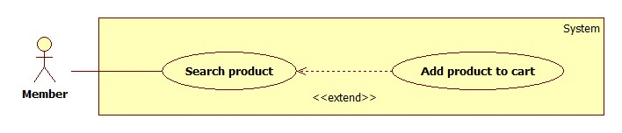

Figure 25: <Member> Add Product To Cart

|  |  |  |  |
| --- | --- | --- | --- |
| **USE CASE – SB020** | | | |
| **Use Case No.** | SB020 | **Use Case Version** | 2.0 |
| **Use Case Name** | Add Product To Cart | | |
| **Author** | Dang Huu Hoang | | |
| **Date** | 20/02/2014 | **Priority** | Normal |
| **Actor:**   * Member. * Guest.   **Summary:**   * This use case allows guest/member to add product to cart.   **Goal:**   * A product will be added to guest/member’s cart.   **Triggers:**   * Guest/Member can add product to cart after search product. * Guest/Member clicks on “Thêm” button on each result row.   **Preconditions:** N/A  **Post Conditions:**   * **Success**: The product will be added to cart. * **Fail:** Product will not be added to cart. Show error message.   **Main Success Scenario:**   |  |  |  | | --- | --- | --- | | Step | Actor Action | System Response | | 1 | Click “Thêm” button on result row. | * Check for the existence of the cart object in session [Exception 1]. * Add clicked product to cart [Alternative 1]. * Notify user. |   **Alternative Scenario:**   |  |  |  | | --- | --- | --- | | Step | Actor Action | System Response | | 1 | The product has existed in cart. | Update quantity of the product. |   **Exceptions:**   |  |  |  | | --- | --- | --- | | Step | Actor Action | System Response | | 1 | Session time out. | * Create new cart object in session. * Add clicked product to cart. * Notify user. |   **Relationships:** Search Product  **Business Rules:**   * Maximum quantity of each product is 10. * Maximum size of cart is 20. | | | |

Table 20: <Member> Add Product To Cart

##### <Member> Propose Price

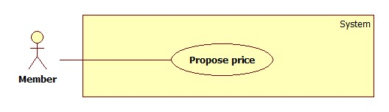

Figure 26: <Member> Propose Price

|  |  |  |  |
| --- | --- | --- | --- |
| **USE CASE – SB021** | | | |
| **Use Case No.** | SB021 | **Use Case Version** | 2.0 |
| **Use Case Name** | Propose Price | | |
| **Author** | Dang Huu Hoang | | |
| **Date** | 20/02/2014 | **Priority** | Normal |
| **Actor:**   * Member.   **Summary:**   * This use case allows member to propose product price.   **Goal:**   * Insert new product price to the database.   **Triggers:**   * Member wants to propose new product price. * Member clicks on “Cập nhật” button on each search result row.   **Preconditions:**   * User has logged in to the system with the role is “member”. * User used search function to find product.   **Post Conditions:**   * **Success**: Propose product price will be inserted to database. Show success message. * **Fail:** Nothing is inserted to the database. Show error message.   **Main Success Scenario:**   |  |  |  | | --- | --- | --- | | Step | Actor Action | System Response | | 1 | Click on “Cập nhật” button on each search result row. | Pop up a window with:   * Giá đề xuất: text box (integer number only, min length: 1, max length: 4), required. * Lưu lại: button | | 2 | Input proposed product price, click “Lưu lại” button. | Updates new product price to the database and show message “Cảm ơn sự đóng góp của bạn”. [Alternative 1; Exception 1, 2] |   **Alternative Scenario:**   |  |  |  | | --- | --- | --- | | No | Actor Action | System Response | | 1 | Price is out of range. | Show message “Cảm ơn sự đóng góp của bạn”. |   **Exceptions:**   |  |  |  | | --- | --- | --- | | No | Actor Action | System Response | | 1 | Price is not a positive number. | Show error “Giá không phù hợp”. | | 2 | Price’s length is not in range. | Show error “Giá không phù hợp”. |   **Relationships:** Search Product  **Business Rules:**   * Average price (avgPrice) = $\frac{minPrice+maxPrice}{2}$* Epsilon $(ε)$ is a number set by staff. $Range ∈[minPrice-ε×avgPrice, maxPrice+ε×avgPrice]$ | | | |

Table 21: <Member> Propose Price

##### <Member> Save Product History

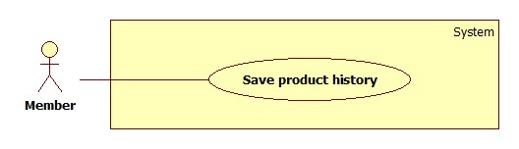

Figure 27: <Member> Save Product History

|  |  |  |  |
| --- | --- | --- | --- |
| **USE CASE – SB022** | | | |
| **Use Case No.** | SB022 | **Use Case Version** | 2.0 |
| **Use Case Name** | Save Product History | | |
| **Author** | Dang Huu Hoang | | |
| **Date** | 20/02/2014 | **Priority** | Normal |
| **Actor:**   * Member.   **Summary:**   * This use case allows member to save their cart.   **Goal:**   * The cart will be saved as member’s history.   **Triggers:**   * Members want to save their cart. * Member clicks “Lưu lại” button.   **Preconditions:**   * User has logged in to the system with the role is “member”. * There is at least one product which was added to cart.   **Post Conditions:**   * **Success**: Information of cart will be added to database. Show success message. * **Fail:** Nothing is added to the database. Show error message.   **Main Success Scenario:**   |  |  |  | | --- | --- | --- | | Step | Actor Action | System Response | | 1 | The member clicks “Lưu lại” button on View cart page. | * Add new cart to database. * Show message “Giỏ hàng đã được lưu thành công” [Alternative 1], [Exception 1]. |   **Alternative Scenario:**   |  |  |  | | --- | --- | --- | | No | Actor Action | System Response | | 1 | The cart has existed in database. | * Update cart to database. * Show message “Giỏ hàng đã được lưu thành công”. |   **Exceptions:**   |  |  |  | | --- | --- | --- | | No | Actor Action | System Response | | 1 | Fail to insert to database. | Show message “Có lỗi xảy ra. Vui lòng thử lại sau”. |   **Relationships:** Add Product To Cart  **Business Rules:**   * The insert time of the cart is current time. * Save product name and current price range. | | | |

Table 22: <Member> Save Product History

##### <Member> Logout

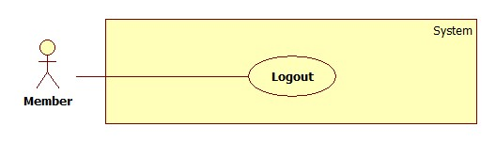

Figure 28: <Member> Logout

|  |  |  |  |
| --- | --- | --- | --- |
| **USE CASE – SB023** | | | |
| **Use Case No.** | SB023 | **Use Case Version** | 2.0 |
| **Use Case Name** | Logout | | |
| **Author** | Doan Ho Anh Triet | | |
| **Date** | 20/02/2014 | **Priority** | Normal |
| **Actor:**   * Member. * Staff. * Admin.   **Summary:**   * This use case allows user to log out of the system.   **Goal:**   * User logs out of the system. User’s current session is destroyed.   **Triggers:**   * User wants to log out. * User clicks “Thoát” link.   **Preconditions:**   * User has logged in to the system.   **Post Conditions:**   * **Success**: User’s current session is destroyed. Redirect to homepage. * **Fail:** Show error message.   **Main Success Scenario:**   |  |  |  | | --- | --- | --- | | Step | Actor Action | System Response | | 1 | User clicks “Thoát” link. | Destroy user’s session. Redirect to homepage. [Exception 1] |   **Alternative Scenario:** N/A  **Exceptions:**   |  |  |  | | --- | --- | --- | | No | Actor Action | System Response | | 1 | Fail to destroy user’s session | Redirect to error page. |   **Relationships:** Login  **Business Rules:** N/A | | | |

Table 23: <Member> Logout

#### <Guest> Overview Use Case

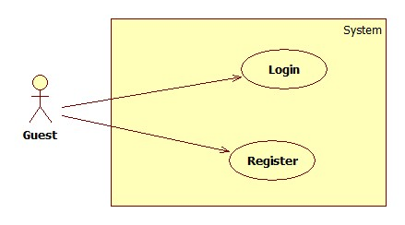

Figure 29: <Guest> Overview Use Case

##### <Guest> Login

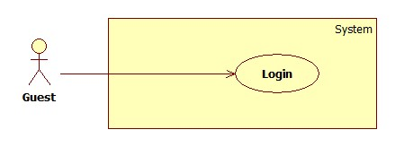

Figure 30: <Guest> Login

|  |  |  |  |
| --- | --- | --- | --- |
| **USE CASE – SB024** | | | |
| **Use Case No.** | SB024 | **Use Case Version** | 2.0 |
| **Use Case Name** | Login | | |
| **Author** | Doan Ho Anh Triet | | |
| **Date** | 20/02/2014 | **Priority** | Normal |
| **Actor:**   * Guest.   **Summary:**   * This use case allows guest to login to the system.   **Goal:**   * Allow authentication and authorization of the system.   **Triggers:**   * Guest want to login into system. * To login: Guests go to the login page, enter username and password, and click “Đăng nhập” button to login.   **Preconditions:** N/A.  **Post Conditions:**   * **Success:** Guest is authorized, redirect to corresponding page. * **Fail:** System will show error on current page.   **Main Success Scenario:**   |  |  |  | | --- | --- | --- | | Step | Actor Action | System Response | | 1 | Guest go to login page. | System show a login form, includes:   * Username: textbox, min length: 6, max length: 30, required. * Password: textbox, password box, min length: 6, max length: 20, required. * Đăng nhập: button. | | 2 | Guess enter username and password into textboxes.  Press “Đăng nhập” button. | Guest is logged into system, authorized with corresponding role. Redirect to corresponding page.  [Exception 1,2] |   **Alternative Scenario:** N/A  **Exceptions:**   |  |  |  | | --- | --- | --- | | No | Actor Action | System Response | | 1 | No input in “Username” or “Password” textboxes | Show error message: “Vui lòng điền đủ username và password!” | | 2 | Username/Password not in range [5,30] | Show error message: “Thông tin không hợp lệ. Vui lòng thử lại!” | | 3 | Input invalid “Username” and “Password” | Show error message: “Thông tin không hợp lệ. Vui lòng thử lại!” |   **Relationships:** N/A  **Business Rules:**   * Each member, staff, admin has an account. * Only active account can log in. * Only member’s account can login from mobile application. | | | |

Table 24: <Guest> Login

##### <Guest> Register

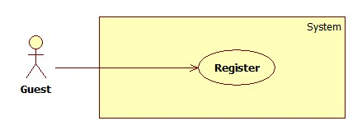

Figure 31: <Guest> Register

|  |  |  |  |
| --- | --- | --- | --- |
| **USE CASE – SB025** | | | |
| **Use Case No.** | SB025 | **Use Case Version** | 2.0 |
| **Use Case Name** | Register | | |
| **Author** | Doan Ho Anh Triet | | |
| **Date** | 20/02/2014 | **Priority** | Normal |
| **Actor:**   * Guest.   **Summary:**   * This use case allows guest to register.   **Goal:**   * User can register new account to become a member of the system.   **Triggers:**   * Guest want to be a member of the system. * To register, click “Đăng ký” in menu bar.   **Preconditions:** N/A.  **Post Conditions:**   * **Success:** New member account is created. * **Fail:** Show error message.   **Main Success Scenario:**   |  |  |  | | --- | --- | --- | | Step | Actor Action | System Response | | 1 | Guest clicks “Đăng ký” link. | System show a register form which includes:   * Username: textbox, min length: 6, max length: 30, required. * Password: textbox, password box, min length: 6, max length: 20, required. * Email: textbox, min length: 0, max length: 100, regular expression: ^[a-zA-Z0-9.!#$%&'*+/=?^_`{|}~-]+@[a-zA-Z0-9](?:[a-zA-Z0-9-]{0,61}[a-zA-Z0-9])?(?:\.[a-zA-Z0-9](?:[a-zA-Z0-9-]{0,61}[a-zA-Z0-9])?)*$, required. * Đăng ký: button. * Xóa trắng: button. | | 2 | Guess enters required information, then clicks “Đăng ký” button. [Alternative 1] | Create new member account. Show success message.  [Exception 1,2, 3] |   **Alternative Scenario:**   |  |  |  | | --- | --- | --- | | No | Actor Action | System Response | | 1 | Guest clicks “Xóa trắng” button. | Clear all input fields. |   **Exceptions:**   |  |  |  | | --- | --- | --- | | No | Actor Action | System Response | | 1 | Length of username is not in range. | Show error message: “Độ dài username phải từ 6-30 ký tự!” | | 2 | Length of password is not in range. | Show error message: “Độ dài password phải từ 6-20 ký tự!” | | 3 | Username’s existed already. | Show error message: “Trùng tên đăng nhập! Vui lòng chọn tên khác!” |   **Relationships:** N/A  **Business Rules:**   * The role of new created account is “member”. | | | |

Table 25: <Guest> Register

## Software System Attribute

### Usability

#### Graphic User Interface

* All the texts, labels and should be written in Vietnamese.

#### Usability

* Admin, staff should need less than one week of training to be productive with the system.
* Guest and member can use the system easily without training.

#### Installation

* The system must be easy to deploy. Customer can deploy successfully and learn to configure, maintain the system within one day of training.
* The mobile app must be easy to install. Compatible with almost Android Phone.
* The attached manual guide must be clear. User can read and do themselves without developer’s help.

### Reliability

* N/A

### Availability

* N/A

### Security

* Privacy: Each role of user has a specific permission to interact with system.
* System always checks authorization and authenticated before doing anything.
* Only admin can grant permission to staff.

### Maintainability

* N/A

### Portability

* N/A

### Performance

* N/A

## Conceptual Diagram

Figure 35: ERD - Conceptual Diagram